NAJUA 2011 Nominations Vita Form

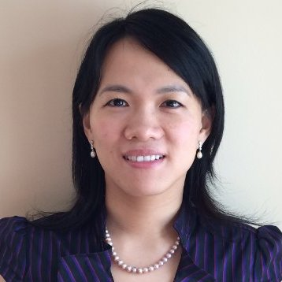 | Nominee Name: Xia, Huan  Position for Nominee: President-Elect  Region: Chicago, USA
Experience (indicate professional, community, and university experience):
- Global Product Development Scientist (2013-present) — McCain Foods Ltd.
- Ingredient Innovation Scientist (2010-2013) — Mars, Inc.
- BOD member (2011-present)— NAJUA
- Secretary (2009-2011)— NAJUA
- Student Representative (2005-2009)— NAJUA
- Process Engineering Intern (2009) — Roquette America, Inc.
- Research Assistant (2002-2009)—Department of Food Sciences & The Huck Institutes of the Life Sciences, The Pennsylvania State University. Expertise in carbohydrate chemistry and plant biotechnology.
- Student Representative (2006-present)—AACC International Biotechnology Division
- Graduate Student Representative (2006-2007)—Department of Food Sciences, Pennsylvania State University
- Student membership (2002-2009)—IFT and AACC International
- Vice President (1999-2000)—Student Association, School of Biotechnology, SYU
Education (indicate institutions, degrees, year, and major fields):
Ph.D.– The Pennsylvania State University, Food Science, December 2009
M.S. – The Pennsylvania State University, Food Science, August 2005
B.E. – Southern Yangtze University, Biotechnology, June 2002

Statement (Vision and Ideas regarding the position nominated with NASYUA): If given the honor as a President-Elect, I would be fully committed to any possible activity that would develop the infrastructure, strength the foundation, and promote the growth of NAJUA. My working proposal would be (1) to lead decision-making process in EC and BOD for major event planning, by-laws review, new initiative proposal; (2) to promote existing and new activities to strength alumni network; (3) to provide constructive opinions towards strategic future development of NAJUA. To achieve these proposed plans, I would work collectively with other BOD and EC members and always be willing to improve the proposal to the way that serves NAJUA members better.
I have discussed the responsibilities of the position with a Nominating Committee member so that I am fully informed of its responsibilities.
Nominee_____________ Huan Xia ________7-8-2016
Signature Date

